1. 資料集說明
   1. 資料比數: 148
   2. 特徵數量: 19
   3. Missing Data: 0
   4. 特徵資訊:

|  |  |  |
| --- | --- | --- |
| **特徵名稱** | **中文特徵名** | **資料型態** |
| class | 類別 | Nominal (normal find, metastases, malign lymph, fibrosis) |
| lymphatics | 淋巴管 | Nominal (normal, arched, deformed, displaced) |
| block of affere | Affere塊 | Boolean |
| bl. of lymph. C | bl. of lymph. C | Boolean |
| bl. of lymph. S | bl. of lymph. S | Boolean |
| by pass | 通過 | Boolean |
| extravasates | 外滲 | Boolean |
| regeneration of | 再生 | Boolean |
| early uptake in | 早期吸收 | Boolean |
| lym.nodes dimin | 淋巴結數減少 | Nominal (integer values in range [0,3]) |
| lym.nodes enlar | 淋巴結數變大 | Nominal (integer values in range [1,4]) |
| changes in lym. | 淋巴結變化 | Nominal (bean, oval, round) |
| defect in node | 節點缺損 | Nominal (no, lacunar, lac. margin, lac. central) |
| changes in node | 節點變化 | Nominal (no, lacunar, lac. margin, lac. central) |
| changes in stru | 結構變化 | Nominal(no, grainy, drop-like, coarse, diluted, reticular, stripped, faint,) |
| special forms | 特殊形狀 | Nominal(no, chalices, vesicles) |
| dislocation of | 錯位 | Boolean |
| exclusion of no | 例外 | Boolean |
| no. of nodes in | 數量 | Nominal (set of values: { 0-9, 10-19, 20-29, 30-39, 40-49, 50-59, 60-69, >=70}) |

二、結果

* 參數設定截圖：

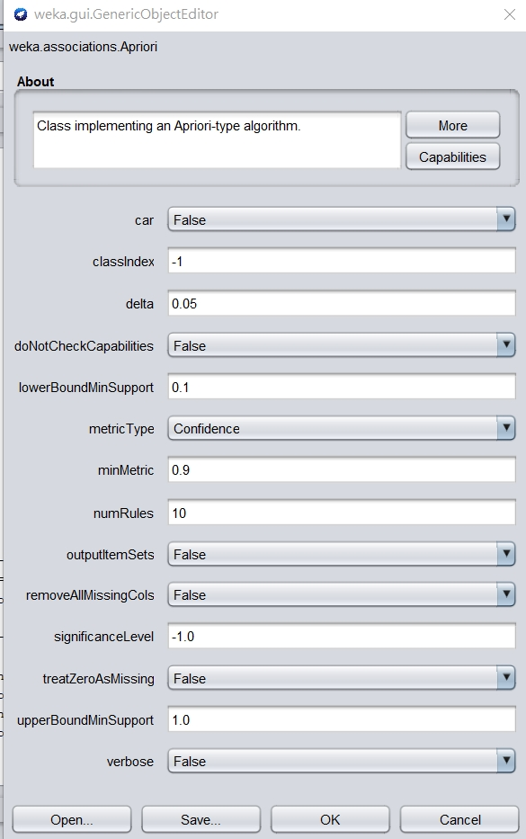

* Rules的截圖：

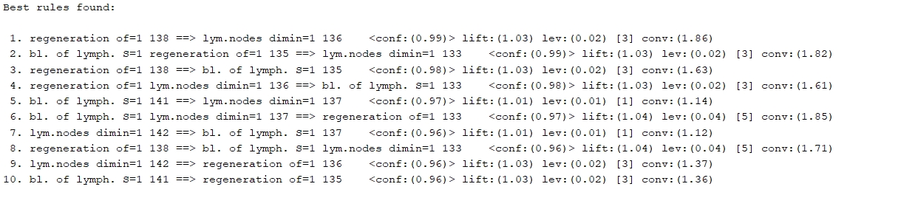

* 任選三條rules說明其意義及計算confidence、lift值(須包含計算過程)
  + 

P(regeneration of ) = P(A) = 138/148

P(lym.nodes dimin) = P(B) = 142/148

Confidence = P(lym.nodes dimin | regeneration of ) =136/138 = 0.98551 = 0.99

Lift =conf / P(B) = 0.99/(142/148) = 1.03183 = 1.03

Conf越接近1表示再生功能與淋巴結的減少關聯性越高

Lift大於1表示再生對淋巴結的減少作用大

* + 

P(regeneration of ) = P(A) = 138/148

P(bl. of lymph.S) = P(B) = 141/148

Confidence = P(bl. of lymph.S | regeneration of ) =135 / 138 = 0.97826 = 0.98

Lift =conf / P(B) = 0.98/(141/148) = 1.02865 = 1.03

Conf越接近1表示再生功能與bl. of lymph. S關聯性越高

Lift大於1表示再生對bl. of lymph. S作用大

* + 

P P(bl. of lymph.S) = P(A) = 141/148

P(regeneration of ) = P(B) = 138/148

P(lym.nodes dimin) = P(C) = 142/148

Confidence = P(lym.nodes dimin | regeneration of & bl. of lymph. S) =133 / 135 = 0.98519 = 0.99

Lift =conf / P(C) = 0.99/(142/148) = 1.02681 = 1.03

Conf越接近1表示再生功能與bl. of lymph. S還有淋巴結的減少關聯性越高

Lift大於1表示再生與bl. of lymph. S對淋巴結的減少作用大